6/1/2025
Daniyal Anwar

Database Standards
By : Daniyal Anwar
Contents
Database Design Diagram 2
Data Dictionary 3
Animal Table 3
Class Table 3
Habitat table 3
Type Table 4
Animal Type Table (bridge table) 4
Color Table 4
Animal Color Table (bridge table) 4
Range Table 5
Animal Range Table (bridge table) 5
Standards Document 5
Summary of Assignment 6

Daniyal Anwar
ISIN325
6/1/2025
SQL DATABASE STANDARD
Project Overview
The SQL Animal Database is designed to manage information about animals, their classifications, habitats, colors, and distribution ranges. It facilitates data retrieval for zoological studies, conservation efforts, and education.

Database Design Diagram
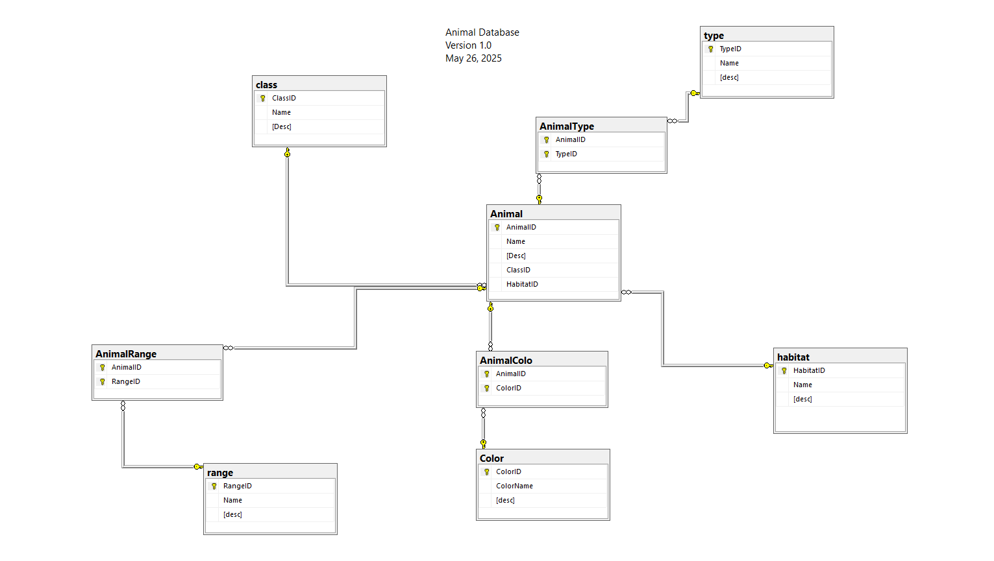

Data Dictionary

Animal Table
Field Name | Data Type | Nullable | Description | Example
AnimalID | Integer | No | Unique animal identifier | 1
Name | Nvarchar(50) | No | Name of the animal | Lion
Desc | Nvarchar(MAX) | Yes | Description of the animal | Big Cat
ClassID | Integer | No | Foreign key to class table | 101
HabitatID | Integer | No | Foreign key to Habitat table | 102

Class Table
Field Name | Data Type | Nullable | Description | Example
ClassID | Integer | No | Unique class identifier | 201
Name | Nvarchar(50) | No | Name of the animal class | Mammal
Desc | Nvarchar(MAX) | Yes | Description of class | Warm blooded

Habitat table
Field Name | Data Type | Nullable | Description | Example
HabitatID | Integer | No | Unique habitat identifier | 206
Name | Nvarchar(50) | No | Name of habitat | Savanna
Desc | Nvarchar(MAX) | Yes | Description of habitat | Grassland

Type Table
Field Name | Data Type | Nullable | Description | Example
TypeID | Integer | No | Unique type identifier | 302
Name | Nvarchar(50) | No | Name of type | Wild
Desc | Nvarchar(MAX) | Yes | Description of type | Living in natural condition

Animal Type Table (bridge table)
Field Name | Data Type | Nullable | Description | Example
AnimalID | Integer | No | Foreign key to Animal table | 1
TypeID | Integer | No | Foreign key to Type table | 103

Color Table
Field Name | Data Type | Nullable | Description | Example
ColorID | Integer | No | Unique Color identifier | 305
ColorName | Nvarchar(50) | No | Name of Color | Golden
Desc | Nvarchar(MAX) | Yes | Description of color | Light, warm yellow

Animal Color Table (bridge table)
Field Name | Data Type | Nullable | Description | Example
AnimalID | Integer | No | Foreign key to Animal table | 2
ColorID | Integer | No | Foreign key to Color table | 106

Range Table
Field Name | Data Type | Nullable | Description | Example
RangeID | Integer | No | Unique Range identifier | 62
Name | Nvarchar(50) | No | Name of geographical range | Africa
Desc | Nvarchar(MAX) | Yes | Description of geographical range | Sub-Saharan region

Animal Range Table (bridge table)
Field Name | Data Type | Nullable1 | Description | Example
AnimalID | Integer | No | Foreign key to Animal table | 6
RangeID | Integer | No | Foreign key to Range table | 108

Standards Document
Type of standard | Description
Vendor Standards | Use Microsoft SQL Server as the primary database management system.
Design Standards | Ensure referential integrity through:  - Primary keys  - Foreign keys  - Indexes  - Database triggers
Database Naming Standards | Names should follow CamelCase convention (capitalize the first letter of each word).  Do not use underscores (_) or spaces.  Common abbreviations:  ID: Identification Number  Desc: Description
Datatype Standards | Numeric: Integer, Decimal  Alphanumeric: Nvarchar, Nchar  Do not use Binary Large Object (BLOB) datatypes.
Security Standards | Use Windows Authentication rather than SQL Server Authentication.  Use of stored procedures and  views, so that applications don’t  have full access to the databases.  No use of embedded SQL in  applications because of security  risks.
Software Standards | Variables must include datatype prefixes for clarity:  - iAnimalID for integer values  - strAnimalName for string values  Data manipulation routines must be developed and managed by database administrators (DBAs).
Change Control Standards | Utilize a staging environment for all database development and updates.  Maintain a detailed change log recording:  - Who performed changes  - What changes were made  - Why changes were necessary  - When changes occurred

Summary of Assignment
Creating this SQL Animal Database has enhanced my understanding of database standards, relational database design, and practices ensuring data integrity and security. It reinforced the significance of thorough documentation and disciplined methodologies for managing structured data effectively.

